K.V.G. COLLEGE OF ENGINEERING
Kurunjibhag, Sullia, D.K.-574 327, Karnataka, INDIA
E-mail: office@kvgengg.com website: www.kvgengg.com

Department of Chemistry

FACULTY PROFILE

Name of the Faculty |  | SATHISHA I B |  |  |  | 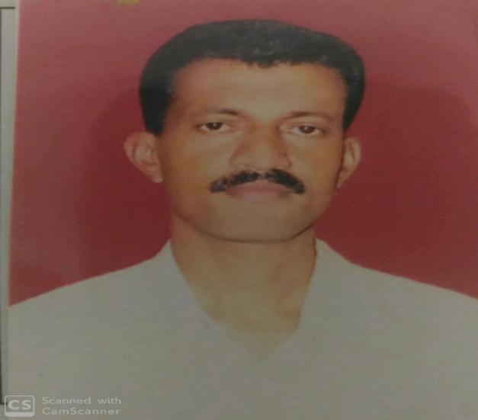
Designation |  | Foreman
Contact Number
 |  | Mobile: +91-9964023860
E-mail ID |  | sathishaibsullia@gmail.com
- Educational Qualification

Qualification | Specialization |  | Year of Passing |  | College &Board
B.Sc | CBZ |  | 1992 |  | Sri Mahaveera college Moodabidri
- Work Experience
Lab Instructor |  |  |  | Sr. Lab Instructor |  |  | FF Foreman
10+Year Experience |  |  |  | 8+ Year Experience |  |  | F1110 10+Year Experience
- Date of Joining to the College
09th May 1994

- In-House Experience
Designation |  |  |  | Duration |  |  |  |  | Department
 |  |  |  | From |  |  | To
Lab Instructor |  |  |  | 09-05-1994 |  |  | 05-12-2004 |  | Chemistry
Senior Instructor |  |  |  | 06-12-2004 |  |  | 26-02-2012 |  | chemistry
Foreman |  |  |  | 27-02-2012 |  |  | Till date |  | Chemistry
- Workshops / Short-termCourse Attended

SL.No. |  | Workshop Title |  |  |  | Place |  |  |  | Date&Year
 |  | Personality Development program |  |  |  | KVGCE, CS Dept, Sullia |  |  |  | 29th and 30th 2001
 |  | Best Practice for Computer Lab Management |  |  |  | KVGCE, CS Dept, Sullia |  |  |  | 12th& 13 Oct, 2012
- Responsibilities Taken in College Level
Event |  |  | Positions |  |  |  |  | Duration
 |  |  |  |  |  |  |  | From |  | From
Annual Sports Meet |  |  | Officials for events |  |  |  |  | 05-03--11 |  | -----
Ayudha pooja |  |  | Rangoli & Decoration Committee |  |  |  |  | 2018 |  | Till the date
- Participation details in the Department level activities
SL.No. | Event |  |  |  | Role / Responsibilities
1 | Library Hour |  |  |  | Incharge
- Awards / Recognition / Achievements/ Others
Mr. SATHEESHA I B, CHEMISTRY DEPT., KVGCE, SULLIA, D.K-574327.
Reach me satheeshaibsullia@gmail.com

